Build a Nutrition Image Analysis Dashboard Using IBM

**1.Introduction**

**• Overview**

Building a Web Due to the improvement in people’s standards of living, obesity rates are increasing at an alarming speed, and this is reflective to the risks in people’s health. People need to control their daily calorie intake by eating healthier foods, which is the most basic method to avoid obesity. However, although food packaging comes with nutrition (and calorie) labels, it’s still not very convenient for people to refer. App-based nutrient dashboard systems which can analyze real-time images of the meal and analyze it for nutritional content can be very handy and improve the dietary habits, and therefore, result in a healthy life.

**B.Purpose**

This guided project aims at building a Web App which automatically estimates food attributes such as ingredients and nutritional value by classifying the input image of food. Our method employs the IBM Watson food model for accurate food identification and Food APIs to give the nutritional value of the identified food.

App which automatically estimates food aApp which automatically estimates food attri

**2.Literature Survey** and nutritional value by classifying the input image of food. assifysta**A.Existing problem**l value by c

lStart with the Serving Size. ...

Check Out the Total Calories. ...

Let the Percent Daily Values Be a Guide. ...

Check Out the **Nutrition** Terms. ...

Choose Low in Saturated Fat, Added Sugars and Sodium.

ically estimates food attributes such asients and nutritional value by classi

**B.Proposed problem**

App-based nutrient dashboard systems which can analyze real-time images of the meal and analyze it for nutritional content can be very handy and improve the dietary habits, and therefore, result in a healthy life.

**3.Theoretical Analysis**

**A.Block Diagram**

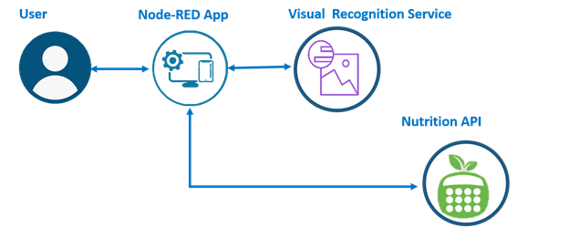

**B.Hardware/Software designing**

**i)Hardware Designing: We use camera to get the video streaming.**

**While running the project in the laptop, we use the laptop camera.**

**ii)Software Designing:**

**Importing the libraries**

**node red - for developing and evaluating models.**

**visualrecognition service - visualrecognition service is mainly used for Classification,**

**Perception, Understanding, Discovering, Prediction and Creation.**

**Opencv-python - using it, one can process images and videos to**

**identify objects, faces, or even handwriting of a human.**

**Image Preprocessing.**

**Import ImageDataGenerator Library.**

**Define the parameters /arguments for ImageDataGenerator class**

**Applying ImageDataGenerator functionality to train set and test set.**

**Model Building**

**Import the model building Libraries**

**Initializing the model**

**Adding node red layers**

**Training and testing the model**

**Video Streaming and alerting**

**Use API to send a message.**

**4.Experimental Investigation:**

**In general, the problems of the Indian tribes can be discussed under**

**the following heads:**

**although food packaging comes with nutrition (and calorie) labels, it’s still not very convenient for people to refer. App-based nutrient dashboard systems which can analyze real-time images of the meal and analyze it for nutritional content can be very handy and improve the dietary habits, and therefore, result in a healthy life.**

**5.Flow Chart:**



**6.Result:**

**• While running the application in local system, the system’s camera**

**will be taken as surveillance camera.**

**• Go to the node red**

**•Then it will colloborte with visual recognition service**

**•And then through the node red it will provide nutrition API.**

**7.Advantages:**

**• Saves the time of the people.**

**• Saves from the health issues.**

**• Will alert the people about the situation.**

**• And alerts the people if the detected image is food.**

**8.Applications:**

**• The project protects the life of tribal people.**

**• Reduces the extinction of animals and many tribal races.**

**• To provide safe and secure life to people.**

**• Reduce the Wild Human conflict.**

**9.Conclusion:**

**The people get notified about the surrounding existence of wild animals**

**with a message and an alert sound through the surveillance camera.**

**10.Future Scope:**

**When the model is trained with thousands of images, the project becomes**

**flawless and helps many tribal races.**

**11.Appendix:**

**A.Source Code:**

**•**

|  |  |
| --- | --- |
| [ |  |
|  | **{** |
|  | **"id": "efb51edb.c2c3d",** |
|  | **"type": "ui_template",** |
|  | **"z": "45b8ca7c.a19504",** |
|  | **"group": "88ac85f9.6b03a8",** |
|  | **"name": "Visual Recog",** |
|  | **"order": 1,** |
|  | **"width": "9",** |
|  | **"height": "8",** |
|  |  |
|  | **"storeOutMessages": true,** |
|  | **"fwdInMessages": true,** |
|  | **"resendOnRefresh": false,** |
|  | **"templateScope": "local",** |
|  | **"x": 90,** |
|  | **"y": 140,** |
|  | **"wires": [** |
|  | **[** |
|  | **"e1ae81d7.cd563"** |
|  | **]** |
|  | **]** |
|  | **},** |
|  | **{** |
|  | **"id": "88ac85f9.6b03a8",** |
|  | **"type": "ui_group",** |
|  | **"z": "",** |
|  | **"name": "Food Image",** |
|  | **"tab": "b82c2072.794df",** |
|  | **"order": 2,** |
|  | **"disp": true,** |
|  | **"width": "10",** |
|  | **"collapse": false** |
|  | **},** |
|  | **{** |
|  | **"id": "b82c2072.794df",** |
|  | **"type": "ui_tab",** |
|  | **"z": "",** |
|  | **"name": "Nutritiona analysis",** |
|  | **"icon": "dashboard",** |
|  | **"disabled": false,** |
|  | **"hidden": false** |
|  | **}** |
|  | **]** |

**11.UI Output Screenshots:**

11.1111UI Output Screen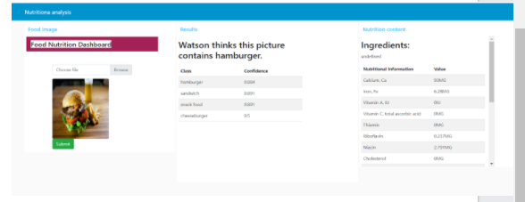shot**sA complete output screen like this, with audio output, will appear on your screen.:**